Soul Feast: An Invitation to the Christian Spiritual Life | 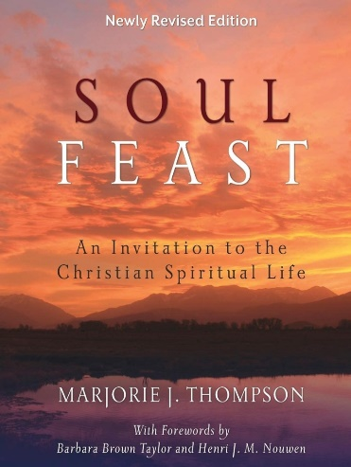
Schedule:
One Saturday per month, 9am -10:30am in the Hospitality Room
Chap | Date | Description
1 | 21-Jan | Hunger and Thirst for the Spirit: The Spiritual Yearning of Our Time
2 | 18-Feb | ​Chewing the Bread of the Word: The Nature and Practice of Spiritual Reading
3 | 18-Mar | Communication and Communion with God: Approaches to Prayer
4 | 15-Apr | Gathered in the Spirit: Our Common Worship
5 | 13-May | Reclaiming Sabbath Time: The Sacred Art of Ceasing
6 | 10-Jun | The Practice of Self-Emptying: Rediscovering the Fast
7 | 16-Sep | Of Conscience and Consciousness: Self-Examination, Confession, and Awareness
8 | 14-Oct | Companions on the Journey: The Gift of Spiritual Direction
9 | 18-Nov | Entertaining Angels Unawares: The Spirit of Hospitality
10 | 9-Dec | Putting It All Together: Developing a Rule of Life

If there are particular topics of interest, please feel free to join anytime.

We will send/post a Zoom link closer to the date (in case of bad weather, illness, etc)
If Lucas County has a level 2 snow emergency we will meet on Zoom only.

In preparation for Session 1 (Jan 21st) please read and reflect on the Introduction and Chapter 1. We will discuss the Group Study questions together.
Session 1 will run one hour as there is a Deacon/Elder retreat at 10am.

Book info:
https://www.amazon.com/gp/aw/d/0664239242/ref=tmm_pap_swatch_0?ie=UTF8&qid=1666790684&sr=8-1
ASIN: B00PAZOQCS
Publisher: Westminster John Knox Press; New Rev edition (September 26, 2014)
Publication date: September 26, 2014

If you need a book, contact Jeannine Crumley or Sandy Townsend
Jeannine Crumley uriah3192@gmail.com
Sandy Townsend sltown@bex.net
Peace and blessings
CPC Christian Discipleship

